Cost for SAR images

Key factors: Resolution, Area covered
Other factors: Revisit time (frequency of images required), Order quantity

Summary:
Commercial prices for SAR images from Govt launched satellites:
1m resolution – 10km x 10km
€ 2000 – around 2L INR
2-3m resolution – 25km x 25 km
€ 1500 – 1-1.3L INR approx.
- ICEYE reportedly charges 6000 to 8000 USD for high resolution images (5L to 6.7L INR)

Pricing table for images from different SAR missions

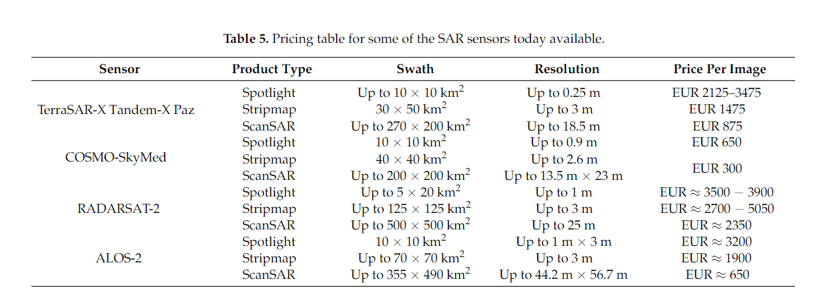

Table 1: Pricing table for some of the SAR sensors available today

Idea of Price per image
Type | Resolution | Area | Price | Price (INR) | Realistic price (INR)
Low resolution | 10m | 50-500 km2 | 200-1,000 USD | 15,000 – 80,000 | 30,000
Medium resolution | 3-5m | 10-100 km2 | 500-3,000 USD | 40,000 – 2,50,000 | 1,25,000
High resolution | 1m | 1-10 km2 | 1,000-10,000 USD | 80,000 – 8,00,000 | 3,00,000

Another metric for price is INR/km2 for a specific resolution
Credit based image cost is preferrable option

Customers Interest:
- Should be able to track changes in a particular area of interest
- Timely delivery
- Reliable
- High-quality (High resolution)

CosmicSAR Satellite Bus Cost Estimate
Previous estimate by Mr. Prabhakar sir.
Sl No | SUBSYSTEM | Estimate | FOREX
1 | SAR PAYLOAD | 300 | 0
2 | DATA PRODUCTS | 0 | 0
3 | STRUCTURE | 25 | 5
4 | THERMAL | 15 | 10
5 | SP DEPLOYMENT MECHANISMS | 5 | 0
6 | RF SYSTEMS | 100 | 89
7 | BASEBAND FORMATTER/DATA HANDLING | 75 | 50
8 | POWER SYSTEMS (Solar Panels, Battery, DC DC Converters) | 150 | 100
9 | OBC BOARD | 150 | 120
10 | ADCS Board | 75 | 50
11 | POWER DISTRUBUTION & CONTROL BOARD | 50 | 50
12 | MEMORY BOARD | 50 | 50
13 | SENSORS (STAR, MAG & 4PI) | 100 | 90
14 | GYROS & REACTION WHEELS WITH ELECTRONICS | 170 | 150
15 | SPS | 50 | 0
16 | REACTION CONTROL SYSTEMS | 0 | 0
17 | ASSEMBLY INTEGRATION AND TESTING | 50 | 30
18 | GROUND SYSTEMS (MGSEs, EGSEs AND Checkout ) | 200 | 100
19 | TESTING AND PRODUCT ASSURANCE | 100 | 0
20 | PROJECT OFFICE EXPENSES | 120 | 20
21 | ADMINISTRATIVE/SALARY EXPENSES | 1000 | 0
22 | CUSTOMS DUTY | 0 | ??
23 | CONTINGENCY/ESCALATION | 0 | ??
PROJECT ELEMENTS-TOTAL |  | 2785
 |  | in Lakhs

Some SAR missions cost for reference
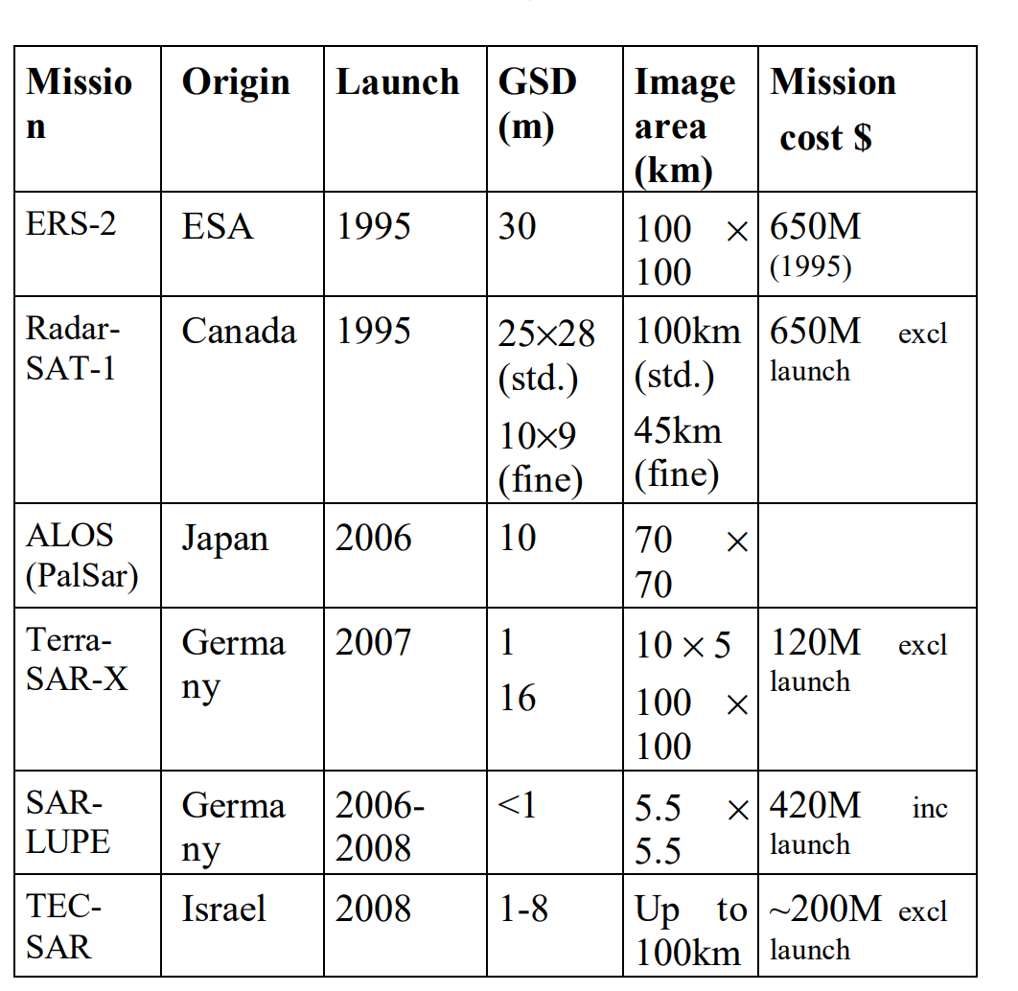
- Capella Space CEO claims they make their satellite in “single-digit millions” which includes development, manufacturing and launch.
- ICEYE satellite takes atleast 5M USD to manufacture and launch [1]

Expected Cost:
Launch | ~7 Cr INR
Satellite Bus | ~40 Cr INR
Payload | ~1 Cr INR
Assembly Integration & Test
Administrative Costs
Ground Station / Mission Control | ~5 Cr INR
Total

References:
[1] https://kyivindependent.com/ukrainian-charity-buys-satellite-for-the-army-how-will-it-help-fight-against-russia/
[2] https://www.satellitetoday.com/technology/2016/12/06/capella-space-ceo-cost-enabling-inexpensive-sar/

